MLX90632 - mBedRock

Product Name : MLX90632 breakout board
Version - 1.0
Category - Breakout Board

The MLX90632 breakout board is a compact breakout board designed for high-precision, non-contact temperature measurement. Built around the MLX90632 infrared (IR) thermopile sensor, this compact 20 x 20 mm board delivers accurate thermal readings via an I2C interface, making it ideal for applications such as wearable health monitoring, industrial temperature sensing, smart home automation, and IoT devices. Operating at 3.3V, it ensures seamless integration with microcontrollers, Raspberry Pi, and Arduino.
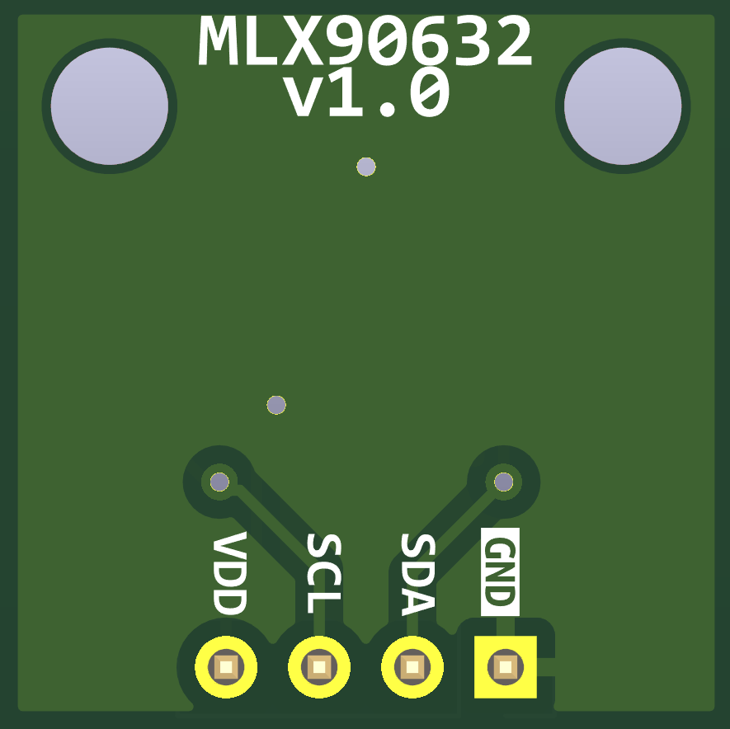
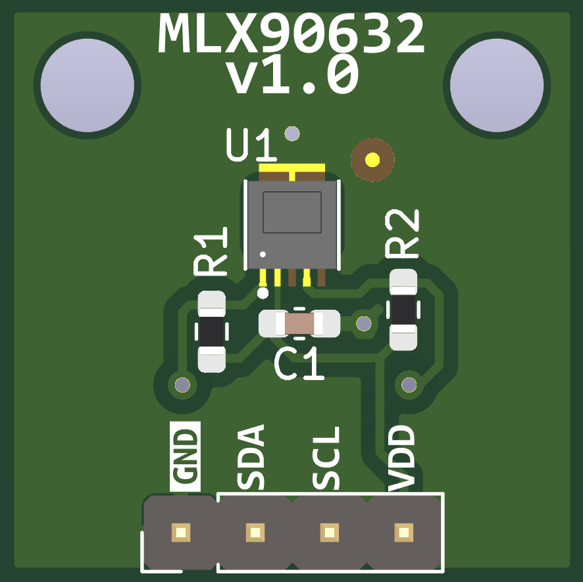
It facilitates the development of all features of MLX6032.

Specifications :

Chip | MLX6032-SLD-BCB-000
Operating temperature range | -20°C to 85°C
Voltage on VDD range | 3V to 3.6V
I2C Voltage | 3.3V
Field of View | 50°
Supply current range | 0.5mA to 1.4mA (no load)


Pin Diagram :
# | Pin Name
1 | GND
2 | SDA
3 | SCL
4 | VDD

